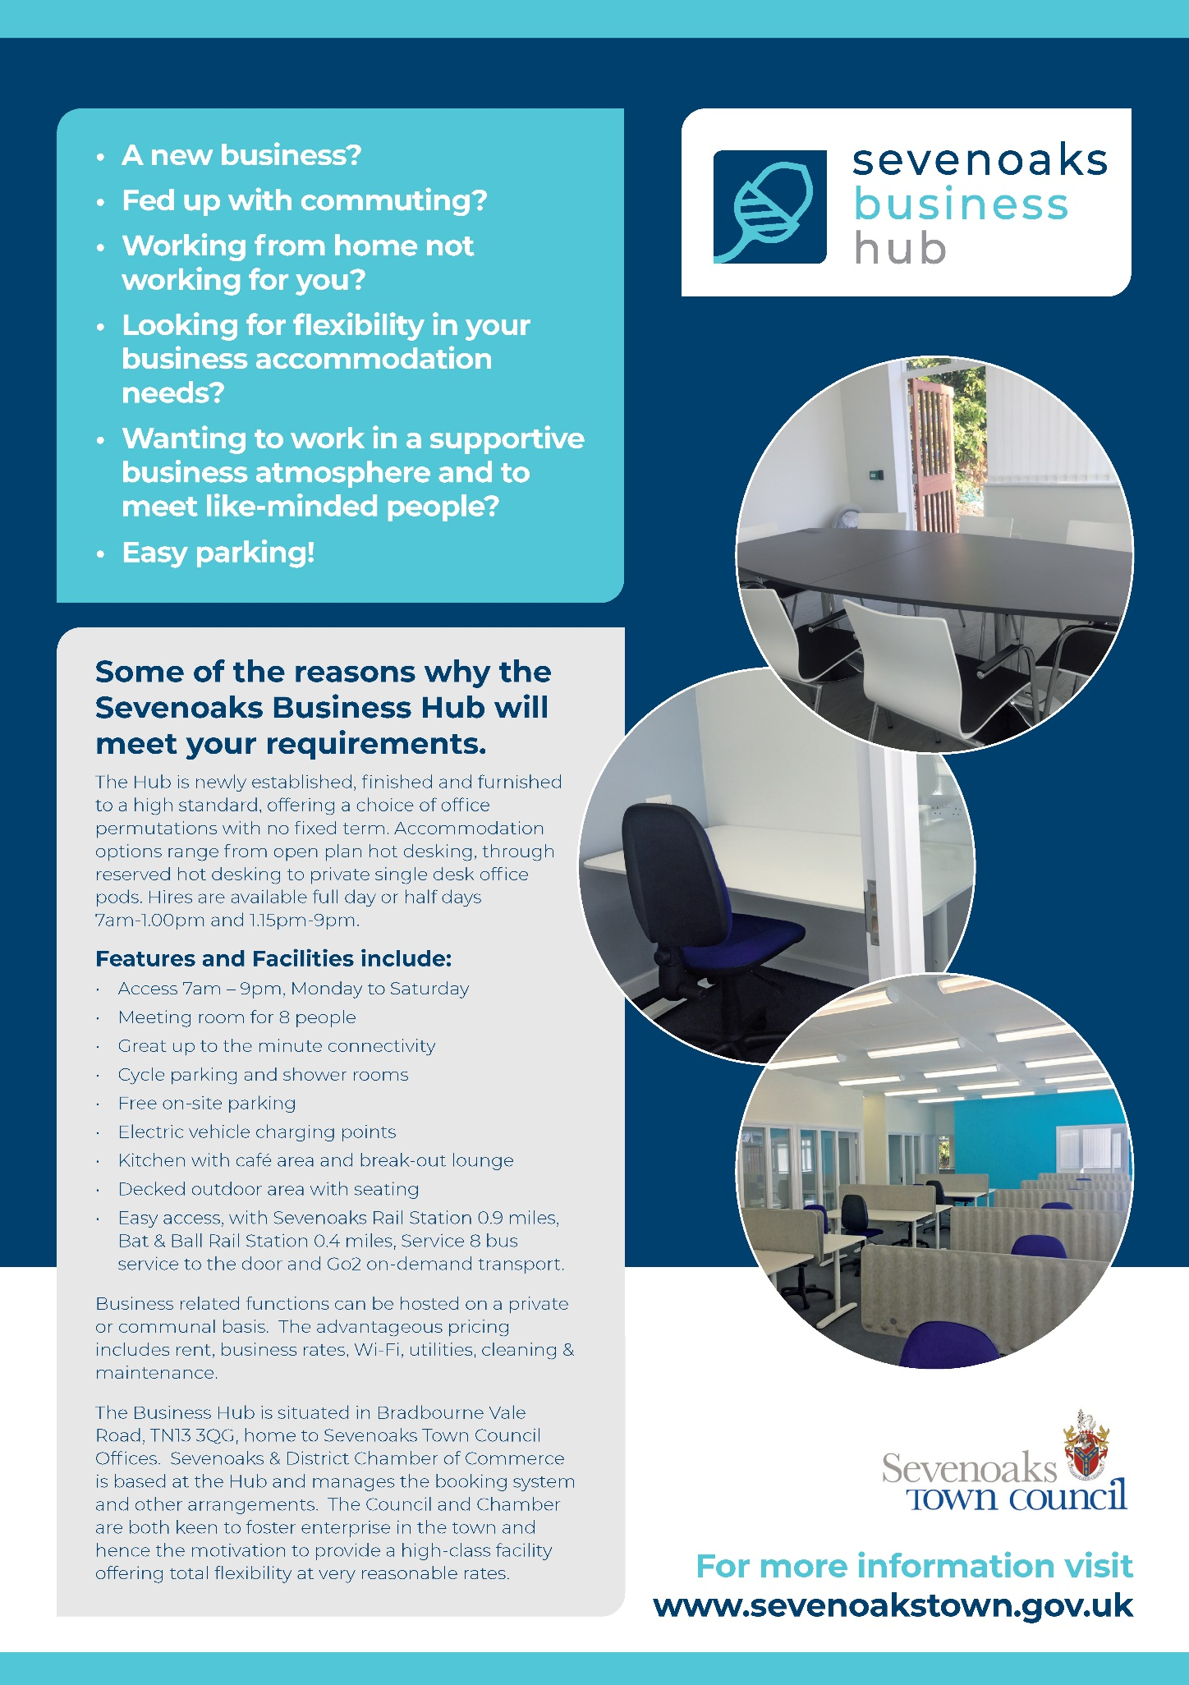

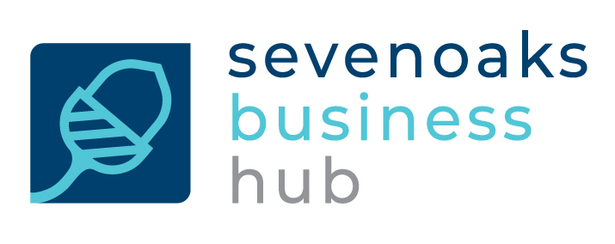
Tariff and Terms & Conditions
TARIFF FROM 1ST JUNE 2021 - MONTHLY RATES (£) INCLUSIVE OF VAT

Hotdesking – per ½ day | Access to a Hot Desk; 7am – 1.00pm or 1.15pm – 9.00pm, to be booked and paid in advance at the time of booking. Date variations are subject to availability. | 10.00
Hotdesking – per day | Access to a Hot Desk; 7am – 9.00pm, to be booked and paid in advance at the time of booking. Date variations are subject to availability. | 20.00
Hotdesking – 8 Days | Access to a Hot Desk up to 8 days per month, all of which need to be reserved at the time of booking. Date variations are subject to availability. | 120.00
Hotdesking – 20 Days | Access to a Hot Desk up to 20 days per month, all of which need to be reserved at the time of booking. Date variations are subject to availability. | 200.00
Dedicated Hot Desk | Unlimited use of a specific Hot Desk, six days a week for a month.  The dedicated desks are in an open plan area.  2 hours free Meeting Room use per month. | 240.00
Private Pod Workspace | Dedicated Desk in enclosed lockable pod.  Unlimited use, six days a week for a month.  2 hours free Meeting Room use per month. | 290.00
Hub Membership | A one-off charge payable at any time to secure lower Meeting Room hire rates | 20.00
Meeting Room  Hub Members  Non-Members | Room seating 8 people  Refreshment facilities available (refreshments available to order)  Hourly Charge  Hourly Charge | 15.00  20.00

Terms & Conditions
All facilities are offered subject to availability.
Hot desking
This works on a” clear desk” basis and hirers will need to remove their equipment and paperwork at the end of each hire period. They will also be required to make sure the desk used is left completely clean.
Private office pods
These are lockable and equipment and paperwork can be left when not in use.
Meeting Room
The room is available on a first come first served basis and needs to be pre-booked. Users are required to make sure it is left in a clean and tidy condition. A coffee machine and cups are available. If additional catering is required, that can be supplied on a charged basis.
Telephone
There are no telephones or lines available for hirers. Hirers are asked to show respect to other hirers when using mobiles.
Kitchen
Facilities include a microwave, kettle, fridge, and freezer. Users must ensure that the room, equipment, and all cutlery & crockery is always left completely clean, tidy, and put away after use.
Showers
Showers must be left in the condition they are found in. Towels are not supplied. Owners must not leave towels, toiletries, or clothing on site.
Car and cycle parking
Subject to availability un-reserved free car and cycle parking is on site. One trade vehicle per hirer, up to the size of a Transit van, is permitted. Car parking is only available when using the Business Hub.
Access
Regular hirers will be issued with a programmed fob to gain access to The Hub. The fob is the property of Sevenoaks Town Council and is to be returned to the Chamber Office at the end of the hire period. The fob will be subject to a deposit of £10.
Security
The last person leaving the building at night is responsible for making sure all windows are closed, all lights are switched off and the alarm set.
User
The Chamber has the right to refuse to hire any or all of the facilities of The Hub to any potential hirer if in its unfettered opinion the prospective hirer or their business are not suitable users. It is against the terms and conditions to re-let the desk space to another person.

Behaviour
In the unlikely event that a member causes a nuisance or distress to any other user of The Business Hub then subject to a fair hearing, their hire is likely to be terminated with immediate effect and without reimbursement of any of the hire charge if the complaint is upheld.
No smoking or vaping is permitted in The Business Hub or within 2m perimeter of any buildings on the site.
Eating at desks is not permitted.
Children
Children under 16 are not permitted.
Pets
No pets are permitted.
Liability
Neither Sevenoaks Town Council or Sevenoaks Chamber of Commerce accept any liability for the equipment, paperwork, vehicles, or other possessions of the hirers. Similarly, no liability is admitted for consequential loss should any event happen which renders the Hub or any of its facilities un-useable.
Regulations
The Chamber will require hirers to accord with any Regulations which are put into place for the good management of The Business Hub.
Review of Terms & Conditions
Hub hirers accept that the Terms & Conditions might be updated from time to time and at all times will accept and accord with the latest version issued.
Permanence
For the benefit of clarity hirers are to be aware that they have no security of tenure.

Sevenoaks Business Hub, Bradbourne Vale Road, Sevenoaks Kent TN13 3QG
Tariff and Terms & Conditions v1. June 2021

