Managing your notifications

If you wish to stop or manage your push notifications using Google Chrome, there are two ways to do this:

The First Way
If you are looking to just change your notification preferences for the Sevenoaks Chamber, then visit the website at www.sevenoakschamber.com. Once you have loaded up the website, you will see bell icon in the bottom right-hand side of the screen. Click this and a pop up will appear.
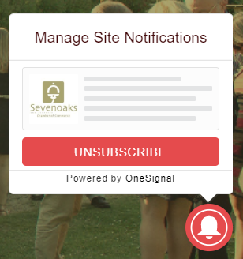

Click “Unsubscribe”, you can re-subscribe at any time.

The Second Way
This way, I will show you how to manage your notification preferences for all websites with a notification feature. Depending on your browser, the following steps may differ but should be relatively similar. I will be explaining how to manage your notifications in Google Chrome.

Open your browser and navigate to menu on the top right, it will look like three dots in a line, like this:

Click on Settings, this will open a new window for your browser settings, you should see a menu on the left-hand side, click on “Privacy and Security”
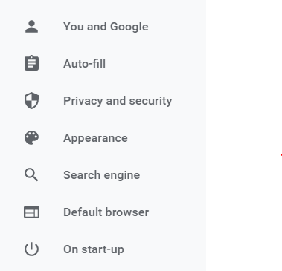

Click on “Site Settings”
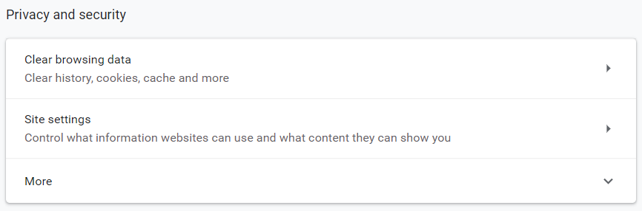

This will bring up a list of permissions.
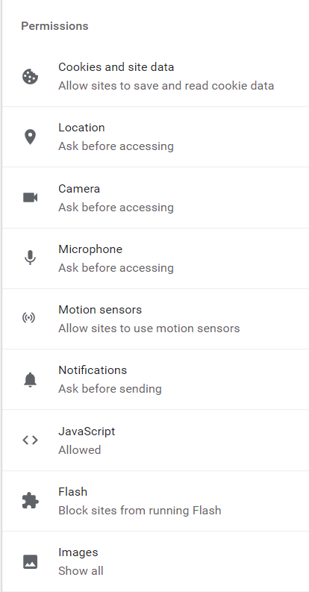

Click on “Notifications”.

This will bring up the settings for notifications as well the websites you have allowed and blocked.
I suggest the following setting be set in the same way they are in the next image; however it is down to your preference.
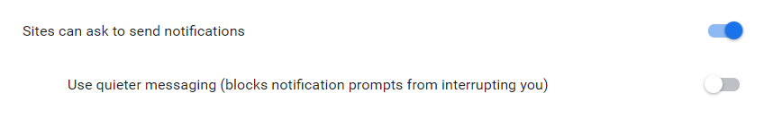
To change a preference for a website, find it on your block / allow list and click on the menu icon (three dots)
Depending on the list the website is on, this menu will allow you to block/allow and remove that website from the list.
Support

If you are struggling to subscribe or unsubscribe to our push notifications or you need a guide on how to manage notifications on safari, please do let us know and we will do all we can to help you.

